
COMP1028 Programming and Algorithm
Session: Autumn 2025
Group Coursework (25%)
Group Name | TFBOYS
Group Members
Name 1 | WeiTian Tang |  | ID 1 | 20805619
Name 2 | HanZhe Qian |  | ID 2 | 20793019
Name 3 | ZhiYuan Zheng |  | ID 3 | 20799972
Name 4 |  |  | ID 4
Name 5 |  |  | ID 5
Marks  Total (100) | Program Functionalities (65) | Bonus (5) | Code Quality (10) | Presentation / Demo (10) | Report / Documentation (10)
Submission Date

1. Introduction
Explain concisely the scope of the project and what your implementation aims to achieve (can be in point form).
The project is in the scope of NLP and cybersecurity which avoids cyberbullying by detecting harmful words and analyzing them to observe nowadays online social environment with advanced programming language.
Aims:
- Use C programming language to do file processing and demonstrate the summary of the data correctly.
- Enhance the skill of using functions and structure properly,creating efficient loops and realizing various sorting algorithm in C programming.
- Have a elementary knowledge of the process of finishing a programming project.

2. Key Design Choices
Describe in concise way the major design decisions in your implementation (can be in point form). Suggested subsections include (delete sections not applicable to you):

2.1 Data structures used (arrays, structs, hash tables, etc.)
We use arrays for the following purpose:
- Use array of the structure to help calculate the word frequency.(WordFreq list[MAX_WORDS] and etc.)
- Use 2D-arrays to store the database from the input files. (char stopDB [100][MAX_LEN] and etc.)
- Use 1D-arrays to store the string or serve as file processing buffer(char filename[100],char cleanBuffer[100] and etc.)
And we also use a structure to help the calculation of the word frequency.

2.2 File handling strategy
1.We use arrays to store the data in the input files to avoid the trouble of repeated input.
2.We support two input file format(txt and csv) for comment file and we convert the csv file into the txt file if the file is detected to be a csv file.
3.We use fscanf function to read the tokenized words word by word.
4.We use string functions(like strstr) and other file processing function (like fgetc) to check the file format and prevent crash or empty file.And we also use file processing function to generate the word analyze reprot.

2.3 Tokenization approach (punctuation removal, case folding, splitting etc.)
We use a function called cleanWord to reserve alphabetic characters and detect “\0” as the end of the string/word.

2.4 Stopword handling
1.We use a function(int) called loadStopWords to process the stopwords file , count the total number of the words in the stopwords file and returns the number .
2.We use another function(int) called isStop to compare the the tokenized words with the stopwords and return 1 (true:is stopword) or 0 (false:not stopword)
3. In the AnalyzeFile function,we use the isStop function when reading the file word by word to detect the stopwords and ignore them by using “continue” in the loop.

2.5 Toxic word detection strategy
1.We use a function(int) called loadToxicWords to process the toxicwords file , count the total number of the words in the toxicwords file and returns the number .
2.We use another function(int) called isToxic to compare the the tokenized words with the toxic words and return 1 (true:is toxic) or 0 (false:not toxic)
3. In the AnalyzeFile function,we use the isToxic function when reading the file word by word to detect the toxicwords.And then we store the detected toxic words into the structure WordFreq toxiclist which will be used in the analysis.

2.6 Sorting algorithm(s) used and justification
1.Bubble sort for descending common words’ frequency:
It is a straightforward sorting algorithm which comparing the adjacent numbers’ value and judge whether to swap.Its logic is easy to understand and can be easily demonstrated in the code.So I choose this algorithm for one of the frequency ordering algorithm.

- Quick sort for descending toxic words’ frequency:
Its logic is more complicated but also more efficient than bubble sort and require recursive and divide-and-merge thinking which mainly depends on a pivot.The function of a pivot is to divide the array again and again when its position in the array is determined by comparing and swapping until the array is sorted.So I choose this algorithm not only to show multiple ways of sorting but also improve the efficiency of executing the code

2.7 Menu-driven user interface design
We create 6 options for user to select and user must load the input file first(select option 1) so the programme the first input of user and judge whether they enter the proper number(1 and 6) instead of enter other numbers or characters.We use switch in a while loop to configure the whole interface which the interface will call the different void functions when entering corresponding options.

3. Challenges Faced and Lessons Learned
Discuss difficulties encountered during development in concise manner. Examples:
- String handling complexities
- Memory management
- Handling large text files
- Efficiency considerations
- etc.
Challenge1:the Quick sort algorithm realization
When we decide to try to use the quick sort for sorting the toxic words frequency, we also start learning the mechanism of the algorithm and we find it difficult to understand and realize it in programming after just watching the animation demonstration of the algorithm.So we search online again for further details and we finally find a Youtube video showing a java programme of the algorithm.Then we “translate” it into C and finally realize the algorithm with a good understanding of the algorithm.

Challenge2:the method to support a csv file
At first, we only know how to process a txt file but the csv file has columns besides lines.
So we have no idea to deal with the comment.csv input.Finally we came up with an idea that we can conver the csv file into a txt file in the programme.We write a temporary txt file to contain the converted content.To enhance flexibility ,we use strcpy function to copy the content directly into temporary file if the input file is txt file so that the comment input can both support csv and txt format.
Reflect on what your group learned about C programming, algorithms, text processing, and working collaboratively.
After finishing the C programming project,we gain a deeper understanding of all kinds of C programming knowledge we learned and eliminate some misunderstanding.For algorithms ,we learned a new sorting algorithm: Quick sort.We can’t help sighing the ingenious design of such efficient algorithm.In terms of cooperation,everybody in the group finish their own task efficiently and perfectly and we absolutely enhance our collaboration experience in the process. But for fulfilling all requirement including some standards for merit and distinction, we have a long way to go.

Appendices (optional)
Include any additional materials, screenshots, tables, etc. (if any)

Appendix A: ReadMe
Provide instructions for compiling and running your program. Example:
- How to compile using gcc / Visual Studio Code / Visual Studio Community or any tool you used
- Required input files (e.g. stopwords.txt, toxicwords.txt etc.)
- Example command-line usage (screenshots)
- Notes on dependencies, e.g. special header files needed to be included (if any)
- Compilation:We use Visual Studio Code and get the interface we programmed(.exe file) after “run and debug”.The interface where programme can be executed is in the exe file.
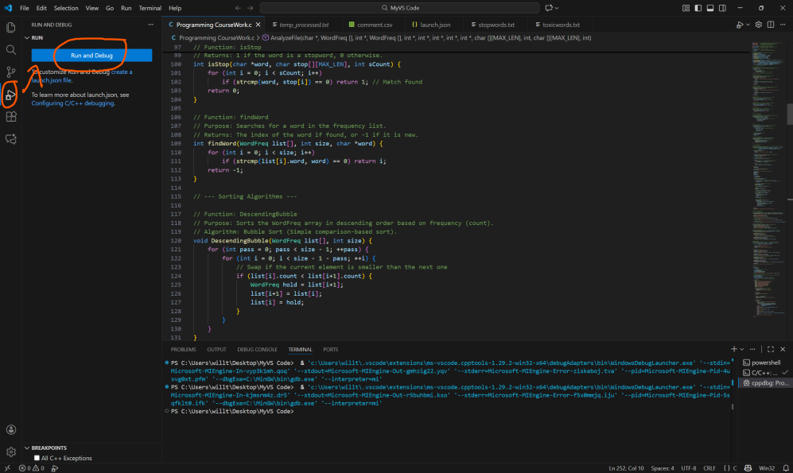
- Input files:comment.csv & toxicwords.txt & stopwords.txt
- Output files:analysis_report.txt & temp_processed.txt
- User Interface:Programming CourseWork.exe

GitHub Link & Video Link
GitHub Repository:zhenq1usiuuu/Programming-and-Algorithm-Lab-Coursework--TFBOYS: The repository to submit our group's Programming and Algorithm Lab Coursework.
(Note: Please also zip all project files and submit a copy to Moodle as well)
Video Presentation Link: https://github.com/zhenq1usiuuu/Programming-and-Algorithm-Lab-Coursework-Video--Group-TFBOYS

Appendix B: Marking Scheme Summary (Optional)
Criteria | Description / Notes
Text Input & File Processing | Load a single .txt file  and process text line  by line. Handle basic  file errors  Support multiple input  files or larger dataset  extracts. Handle edge  cases
Tokenization & Word Analysis | Split text into words,  normalize (lowercase,  strip punctuation),  count total words and  unique words.  Implement lexical  diversity metrics  (unique/total ratio),  average sentence length,  advanced statistics.
Toxic Word Detection | Detect toxic words  using a provided  dictionary  (toxicwords.txt),  count occurrences,  report frequency
Sorting & Reporting | Sort words  alphabetically OR by  frequency using a  basic algorithm (e.g.,  Bubble Sort). Display  top N frequent words.  Implement multiple  sorting algorithms (Quick  Sort) and  compare results. Display  top toxic words  separately.
Persistent Storage | Save analysis  summary to an output  file  (analysis_report.txt).  Reload stopword and  toxic dictionaries  from file.
User Interface | Menu-driven text  interface with options  to load, analyze,  display, save, and  exit. Provide clear  user prompts.
Error Handling & Robustness | Handle invalid inputs  gracefully (e.g.,  wrong filename).  Prevent crashes on  simple errors.  Anticipate more complex  failures (e.g., corrupted  Files)
Code Quality & Modularity | Use functions for  modularity  Use of  data structures (structs,  arrays of structs) for clean design
Bonus Features | None
Presentation / Demo | Video recording  explaining the basic  features and functions  of the program. Video  length is less than 5  min or longer than 10  min.  Video recording  explaining clearly the  features and functions of  the program in relation to  the code. Provided  justification to the choice  of techniques. Video  length is within 5 – 10  min.
Report / Documentation | Students’  documentation of  document their  approach, choices,  and challenges,  limitations and  possible  improvements are  descriptive and lack  of depth.  Students document their  approach, choices, and  challenges critically.  Reflect on limitations and  possible improvements  critically

Note: This may help to ease the marker on having an overview of your entire project in a glance.

